









**Implementation Phase: Final Output(no error)**

**Step 1: Add Devices**

1. Open **Cisco Packet Tracer**.
2. **Add devices:** Drag and drop a **PC**, **Server, switch,router.**
3. Connect them using a **copper straight-through** cable.

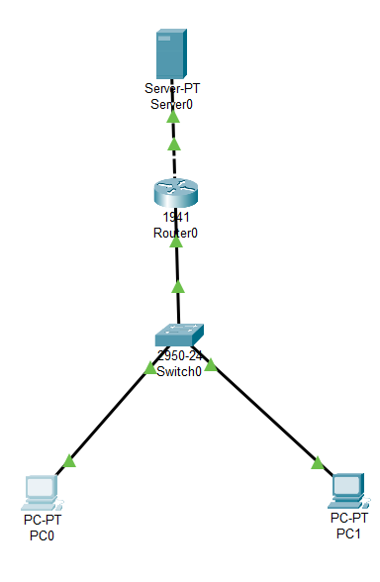

**Assign IP Addresses:**

* PC: **192.168.0.1 / 255.255.255.0**
* FTP Server: **10.10.10.2 / 255.255.255.0**

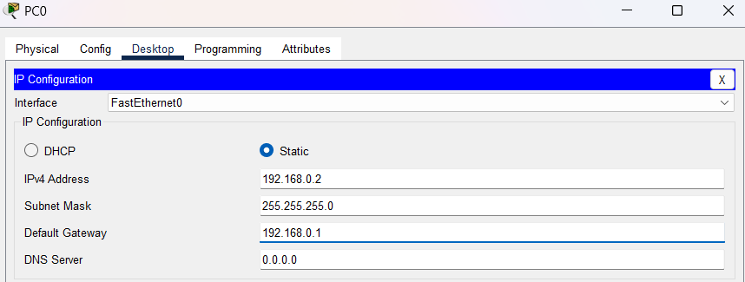

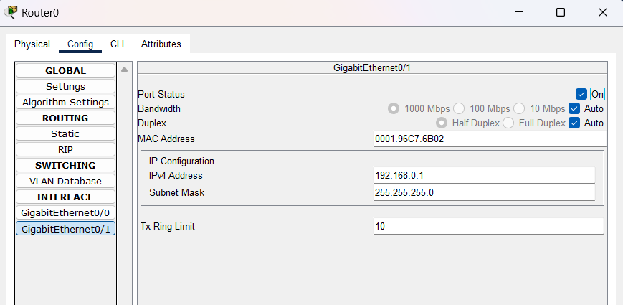



**Implementation Phase: Final Output(no error)**

**Step 2: Click on the Server → Go to Services tab → Select FTP.**

**Add a new FTP user:**

* **Username: cisco2**
* **Password: test**
* **Check Write and Read Access.**

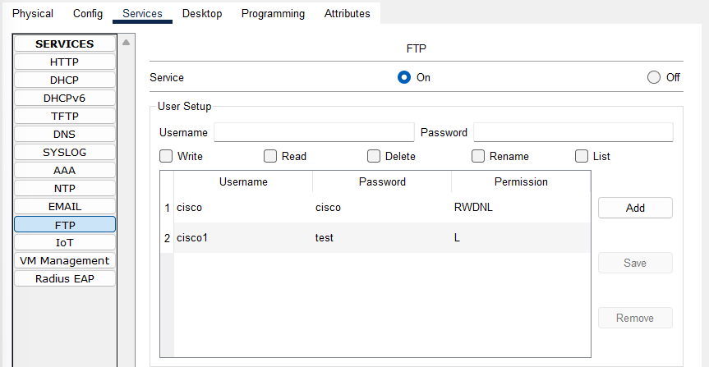

**Upload some sample files for testing.**

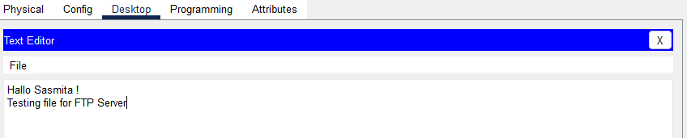

Open the **Command Prompt** on the PC.

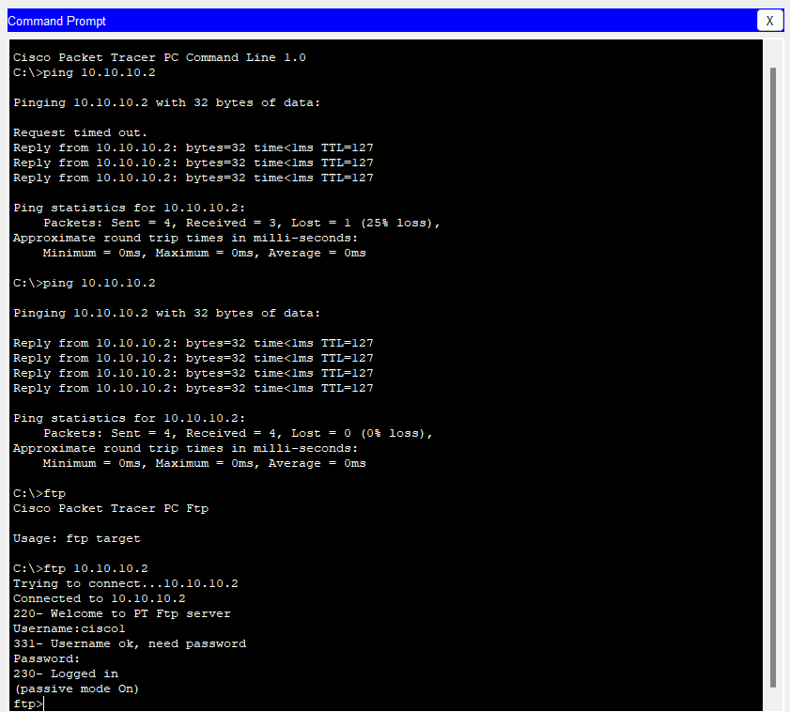



s

After the succesful transfer of file , check them by dir





        
        
        
        
        
        
        
        
        



